OATS Trouble Shooting (in the windows search “services”-> Service page will open)

1. **Oracle ATS Helper- It helps to connect OATS to browser (Always up and running).**

If any issue we will find which is OATS facing trouble to connect the browser, then Oracle ATS Helper needs to be restarted. It should be up and running.

To reach all the Oracle services installed, here is the navigation

Type services in the search tool bar on the desktop, which can open the services details.

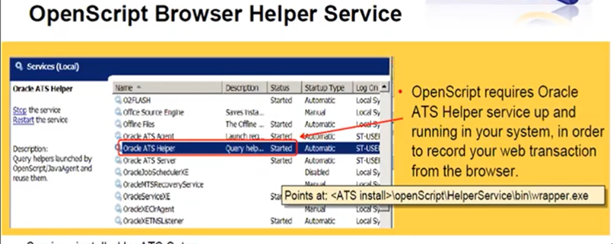

1. **Oracle ATS Agent – It helps to connect the OTM.**

If any issue we will find to connect to OTM, please restart the Oracle ATS Agent. It should be up and running.

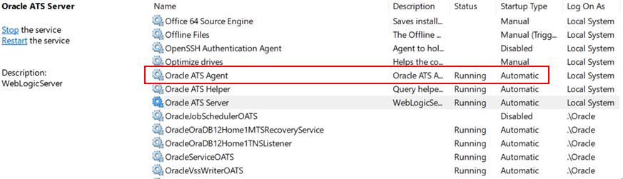

1. **Oracle ATS Server – It helps to connect with OATS server.**

If any issue we will find to connect to OATS, please restart the Oracle ATS Server. It should be up and running all the time.

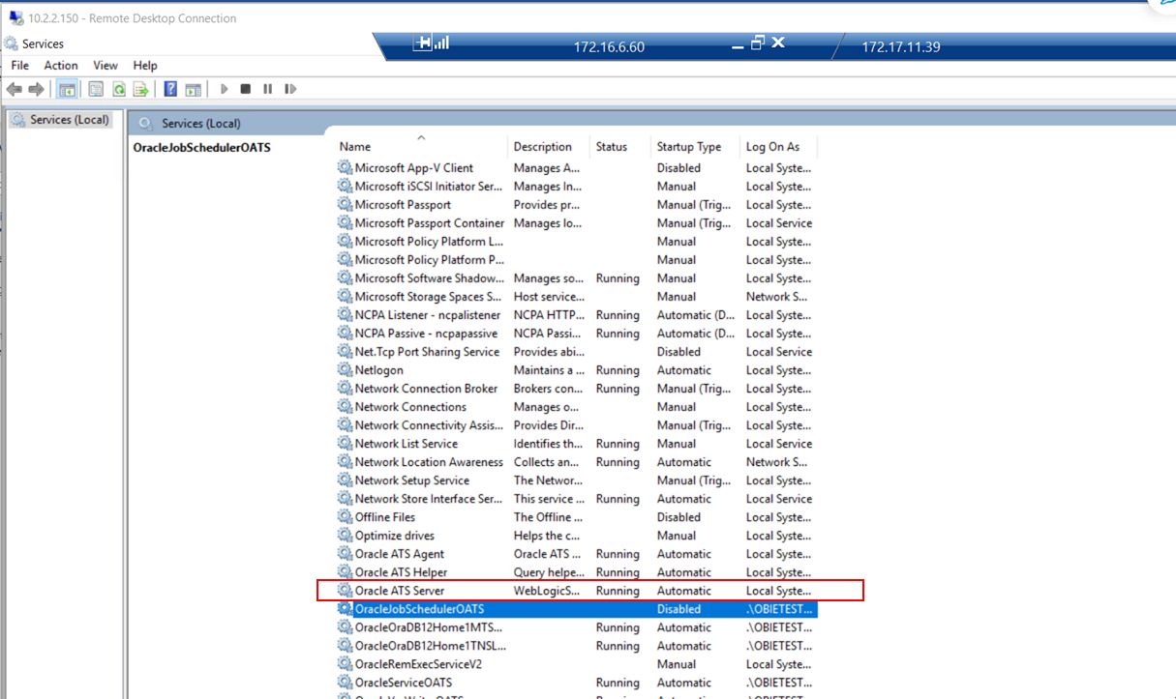

4) Right clicking on any item (test case, requirement, issue, folder, etc) does not ever display the pop-up shortcut context menu options

Cause

An Internet Explorer Compatibility View setting was enabled

Bug 29581832 OTM Application Context Menu Does Not Pop Up In Intenet Explorer

Solution

1. Press F12 in the browser to bring up the Developer Tools and go to the Emulation tab

2. Verify the "Document mode" is higher than 7

3. Open the Compatibility View Settings from IE's Tools menu

4. Uncheck the option 'Disable intranet sites in Compatibility View'